ECOMMERCE
E-PROJECT REPORT

APTECH LEARNING SHAHR-E-FAISAL

MUHAMMAD TAHA (Student ID: 1525923)
UMER SIDDIQUE (Student ID: 1529753)
HAFEEZ HUSSAIN (Student ID: 1440395)
MARWA TARIQ (Student ID: 1526717)
BILAL KHAN (Student ID: )
TANVEER HUSSAIN (Student ID: )
Contents
Acknowledgments 2
- Introduction 3
- Objectives 3
- Problem Statement 3
Problem Solution Through Coding 4
Coding Approach 4
Once we recognized the difficulties highlighted in the problem statement, our team started a coding journey to find a useful solution. We decided to use HTML, CSS, JS, REACT and BOOTSTRAP 5 as our main programming language because it's great for building dynamic and interactive websites. PHP works well with web development and smoothly connects with databases, making it the perfect fit for our project. 4
Website Development 4
Technical Implementation 4
- Conclusion 8

Acknowledgments

I would like to extend my sincere gratitude to Sir Talib for his invaluable guidance, mentorship, and unwavering support throughout the development of this project. His expertise and encouragement have been instrumental in the successful completion of the eProject.

I would also like to acknowledge the dedicated efforts of my talented team members, with whom I collaborated closely:

MUHAMMAD TAHA

MARWA TARIQ

UMER SIDDIQUE

HAFEEZ HUSSAIN

BILLAL KHAN

TANVEER HUSSAIN

Their commitment, teamwork, and individual contributions have significantly enriched the project, making it a collaborative success.

Thank you to Sir Talib and my esteemed team members for their hard work and commitment to excellence.

Introduction

The IT world is changing fast, and to keep up, we need to keep learning and using what we learn. But sometimes, our busy schedules and where we live make it hard to apply what we've learned. That's where our project, called "eProject," comes in. It's like a helpful learning space that makes it easier to connect what we learn in theory with real-life situations.

Objectives

The primary objective of this program is to provide a hands-on experience with real-life projects. The focus is not merely on teaching concepts but on presenting real-life scenarios that empower participants to create applications using relevant tools. The eProject aims to:
  - Foster a step-by-step, laddered approach to learning.
  - Facilitate the development of larger, more robust applications.
  - Encourage the use of utilities in user-designed applications.
  - Promote unified coding for complete applications.
  - Guide learners in implementing concepts progressively.
  - Enhance skills and add practical value.
  - Provide exposure to real-life projects.
  - Create complex and useful applications through a mentor-supported, phased approach.

Problem Statement
FIRST FASHION is selling various types of fashion products.The company advertises by distributing the pamphlets, advertising on television and so on. Due to rapid development in internet field, the company decides to launch a website where people will get all the information about the various products available with them easily.

Problem Solution Through Coding

Coding Approach

Once we recognized the difficulties highlighted in the problem statement, our team started a coding journey to find a useful solution. We decided to use PHP as our main programming language because it's great for building dynamic and interactive websites. PHP works well with web development and smoothly connects with databases, making it the perfect fit for our project.

Website Development
The core of our solution revolves around the creation of a comprehensive website that addresses the needs outlined in the problem statement. The website caters to user.

Website Screenshots

Website Header:
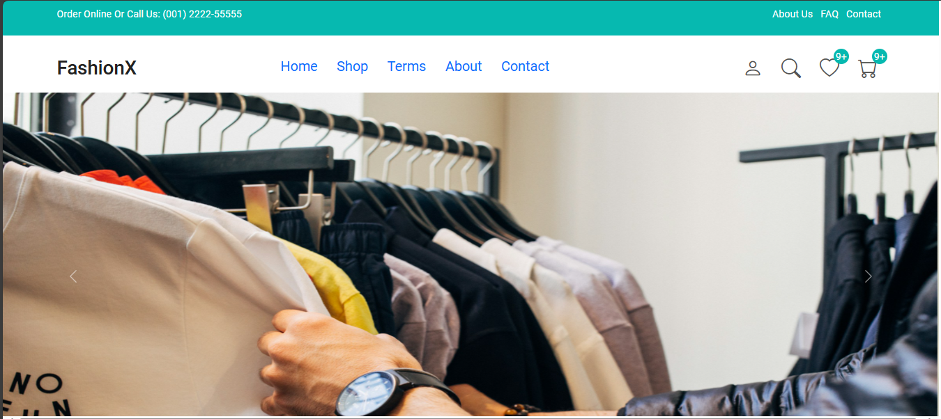

Category Page:
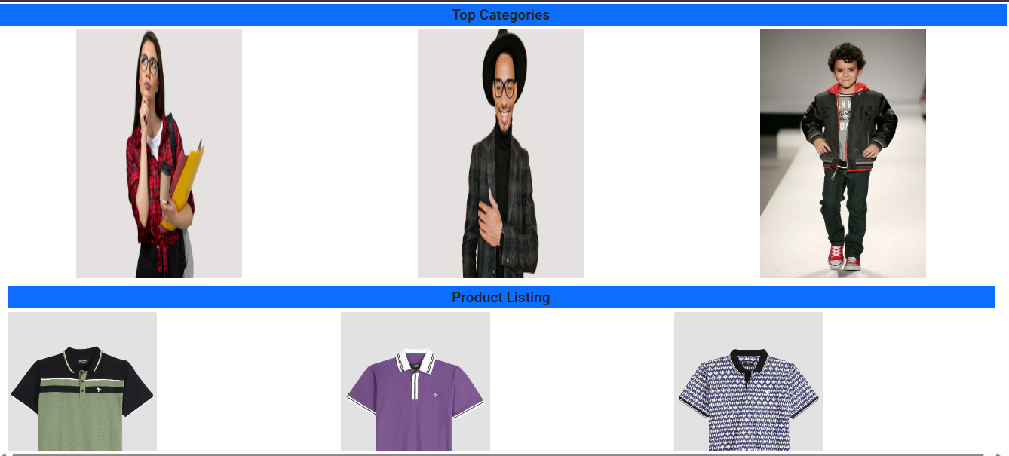

Cart Page:

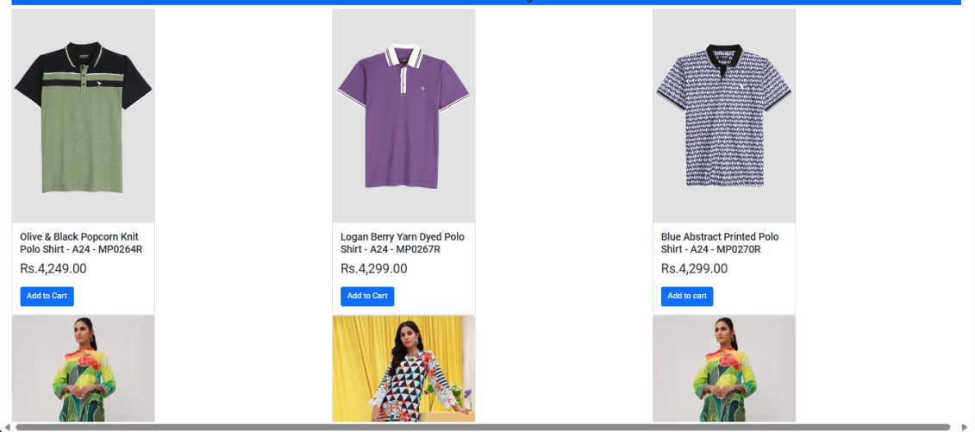

Code Samples

Code.html:
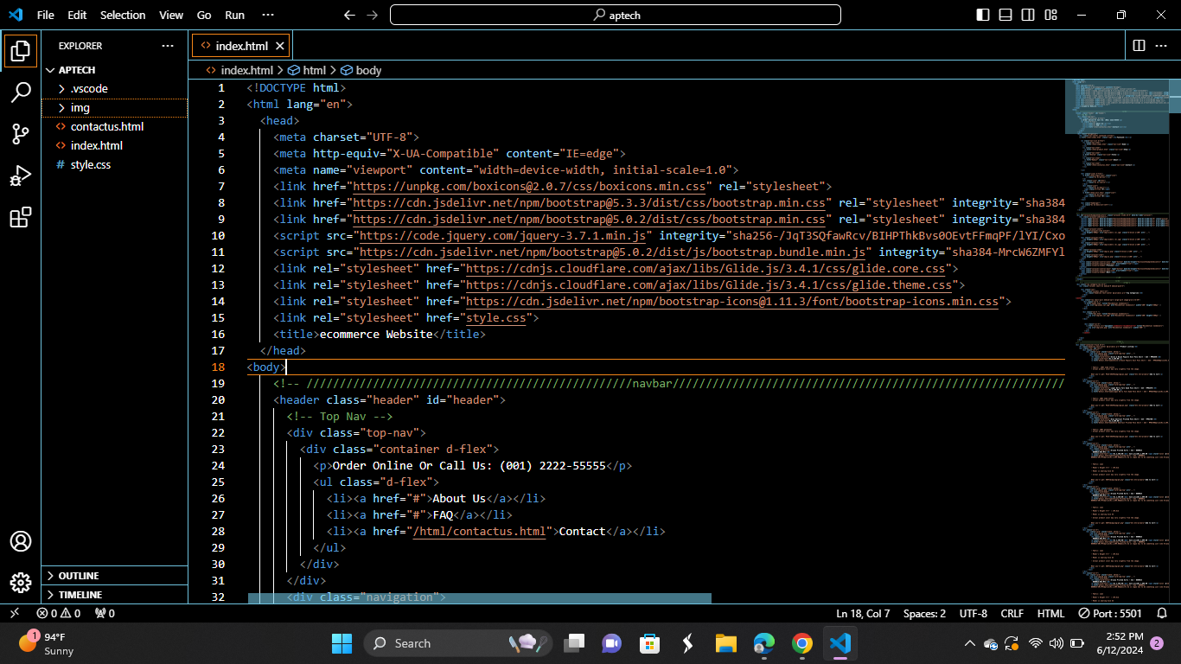

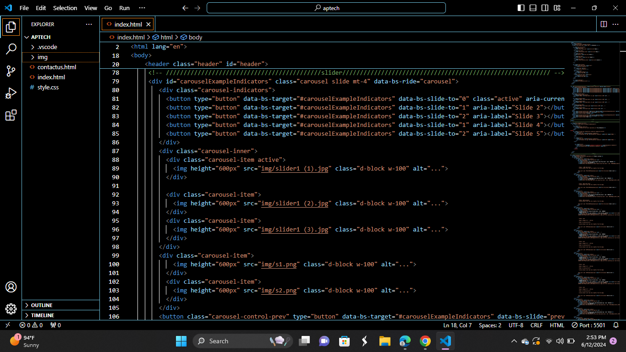

Code.css:
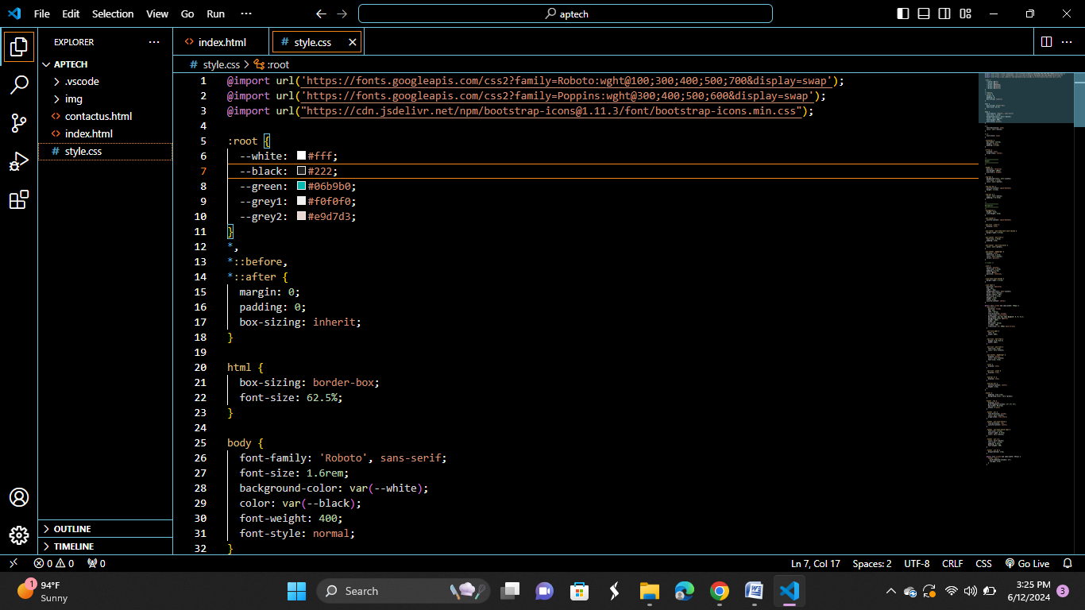

7. Conclusion

In conclusion, the eProject is a successful solution to the challenges in the IT industry. Our user-friendly website, powered by HTML, CSS, JS, REACT and BOOTSTRAP, creates a practical learning environment. We've designed it for users.
Thanks to our team's efforts and guidance from Sir Talib, we've built a robust tool for IT professionals to apply their skills. Looking ahead, we're excited to enhance and expand the eProject for the evolving needs of IT education. This project not only solves a problem but also boosts our confidence to tackle future challenges in the dynamic field of information technology.

